**Auto Air-Calibration**

Steps to perform auto air calibration through cron job in peripheral service :-

1. Go to the directory /opt/hexwave/etc/hexwave_properties/ and edit the .properties file of peripheral service.

sudo nano /opt/hexwave/etc/hexwave_properties/.peripheral_service.properties

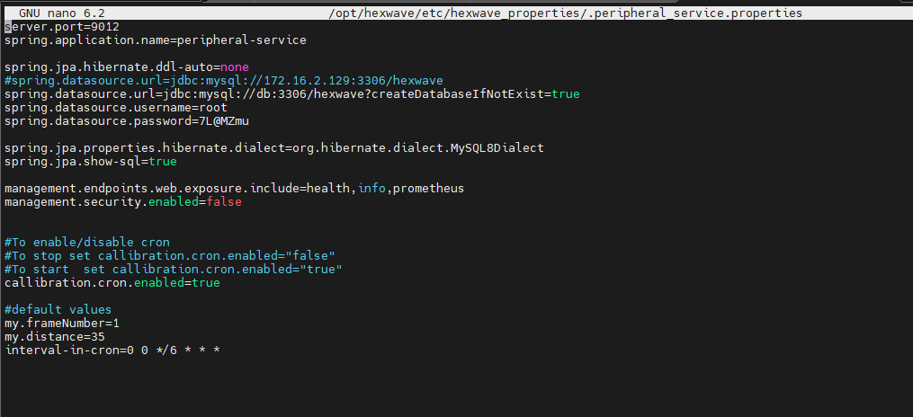

1. Here, the parameter **callibration.cron.enabled** is used to enable or disable the cron job in peripheral service.

3. Parameter **my.framenumber** is used to set number of frames.

1. Parameter **my.distance** is used to set distance of air.
2. Parameter  **interval-in-cron** is used to set the interval in which cron job will run.
3. Changes to stop and start cron job are:-
4. To enable cron job to perform air-calibration set-

**callibration.cron.enabled=true**

1. To disable the cron job set-

**callibration.cron.enabled=false**

1. In .peripheral_service.properties file other variables that are used to set number of frames and the distance.The default values of these variables are:-

my.frameNumber=1 [ the default number of frames is set to 1]

my.distance=35 [ default distance in inches is set to 35 inches]

1. The parameter used to run cron job in fixed interval is **interval-in-cron** and is default set to 6 hours i.e cron job runs after every 6 hours.

**interval-in-cron=0 0 */6 * * \***

We can change this cron job expression ”**0 0 */6 * * \***” to change the interval.

Here are some common expression:

To run every second - * * * * * *

To run every five minutes - 0 */5 * * * *

To run every hour - 0 0 * * * *

1. When our cron job is running we can see our image at **/data/tmp** directory. Timestamp of directories will change when our new image will store.
2. Also frames are formed in directory **/data/tmp/target** whatever number we had selected from 1 to 10 corresponding frames will form here.